**Assignment 1 - Plane rotations**

Guided by Professor Rachel McDonell

Implemented by: Yuzhou Shao

Student id: 19322035

Youtube Demo: <https://youtu.be/byU8sMr2tAY>

# Examinations:(the explanation of the code the details are in the next section)

**Simple representation of a plane with pitch, roll, and yaw rotations, using Euler Angles**

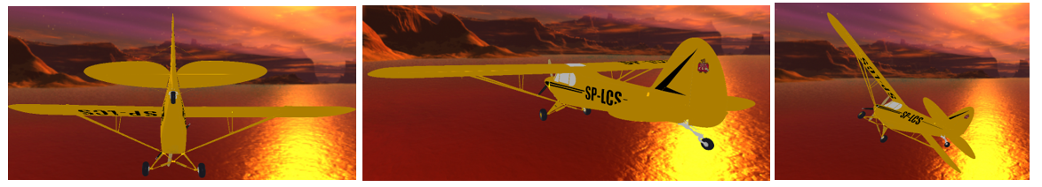

**Overcome gimbal-lock using quaternions to represent the rotations(explained more details on my video)**

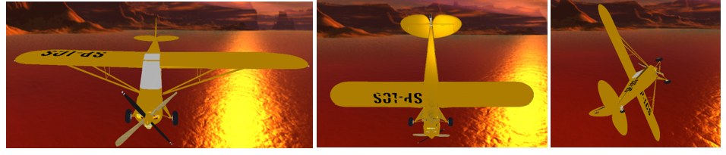

**Hierarchical moving elements (e.g., propeller, wheels)**

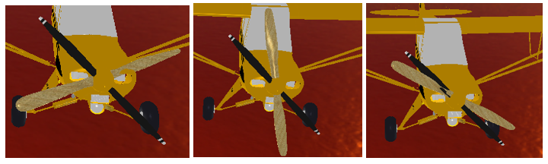

**Switch between first-person and third-person views**

**1st person- view 3rd person- view**

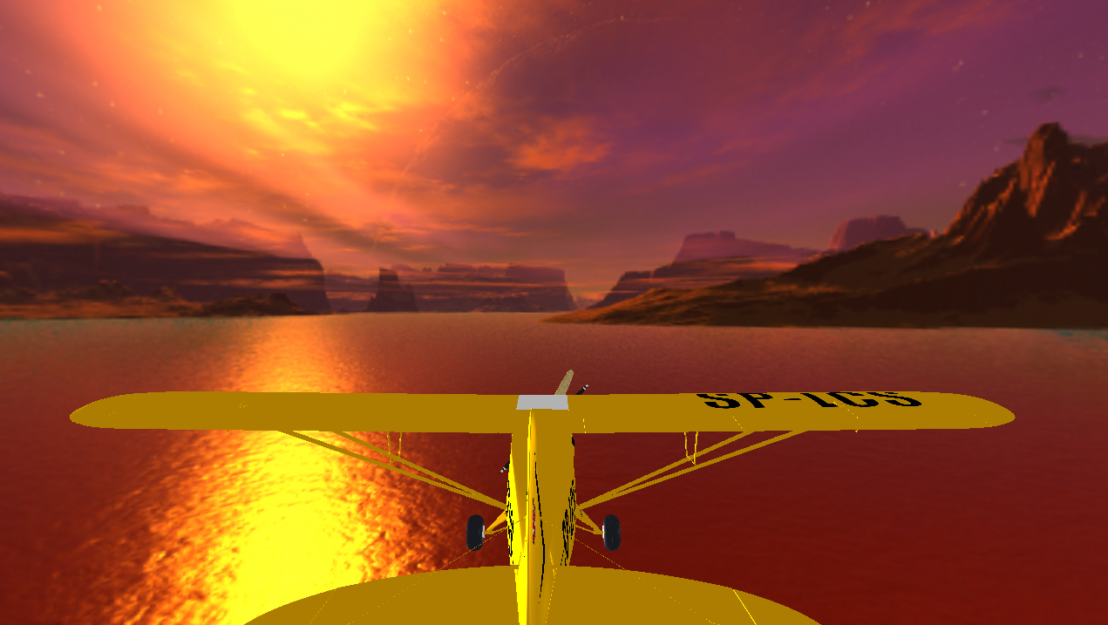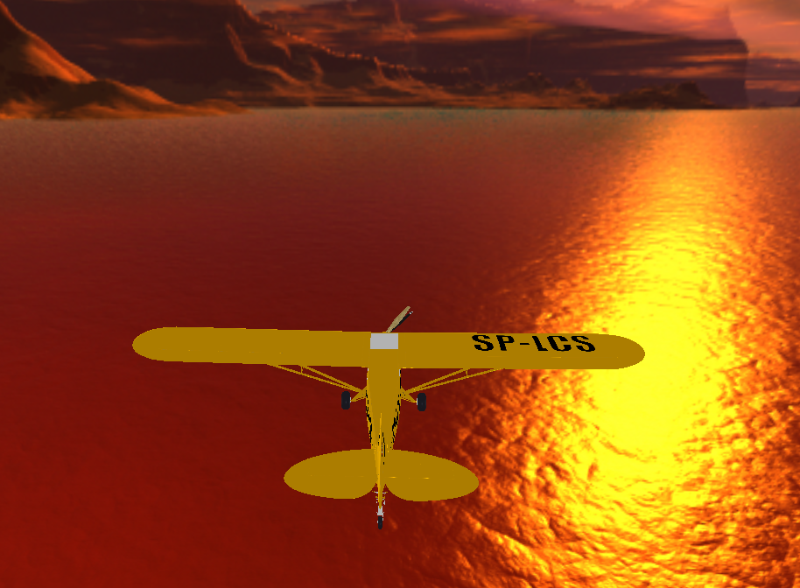

**Good visual appearance of the plane (e.g., Using 3D model rather than Cylinders)**

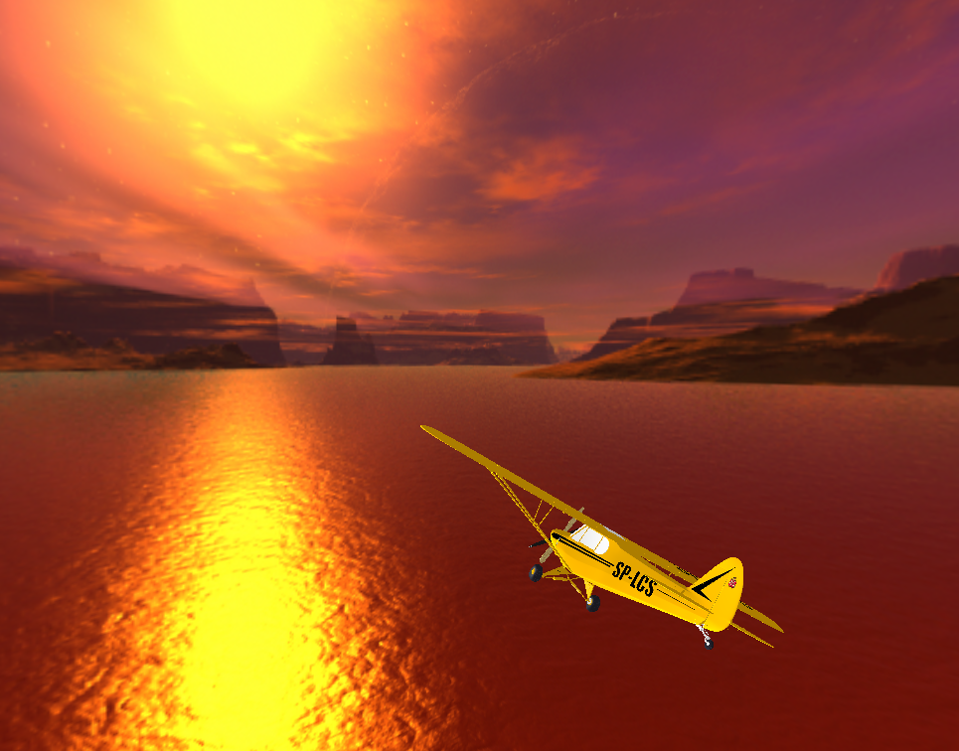

**Other, a skybox**

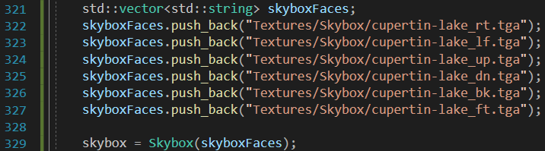

# Explanations:

**1.Create a simple model of an Aeroplane:**

I have loaded an obj file of an Airplane 3D model from [Airplane OBJ Models for Download | TurboSquid](https://www.turbosquid.com/3d-model/airplane/obj)

I used Assimp techniques to load it.

Configurating Assimp in Visual Studio C++ Property Pages

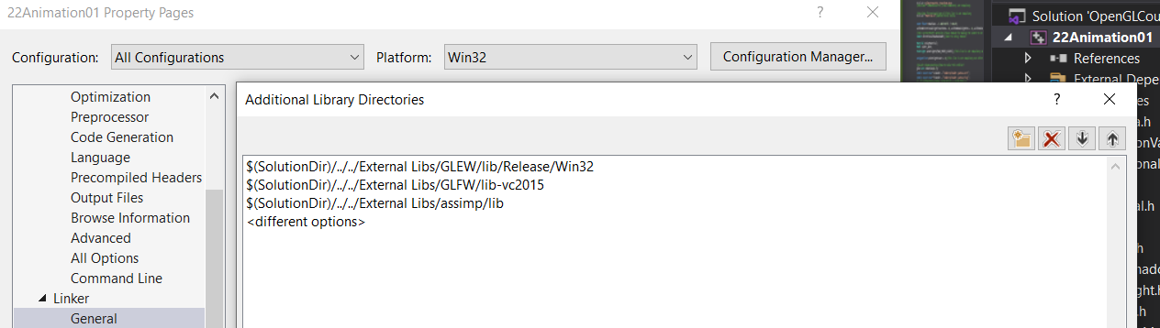

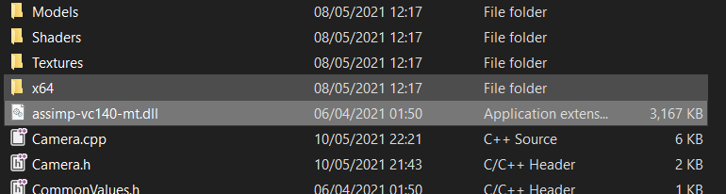 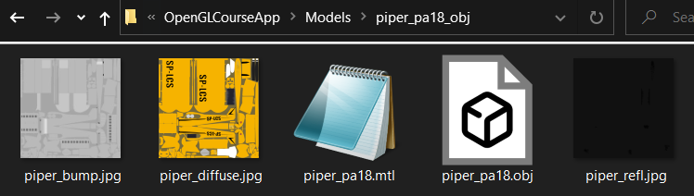

Local location of the downloaded Assimp.dll file(left) and Aeroplane Obj files(right)

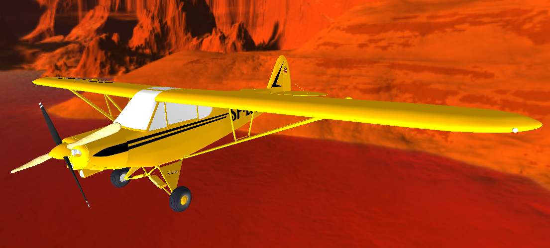

Aeroplane output in the scene

**2.Use the keyboard and mouse input to display pitch, yaw and roll rotations of the plane.**

Output of pitch, yaw and roll

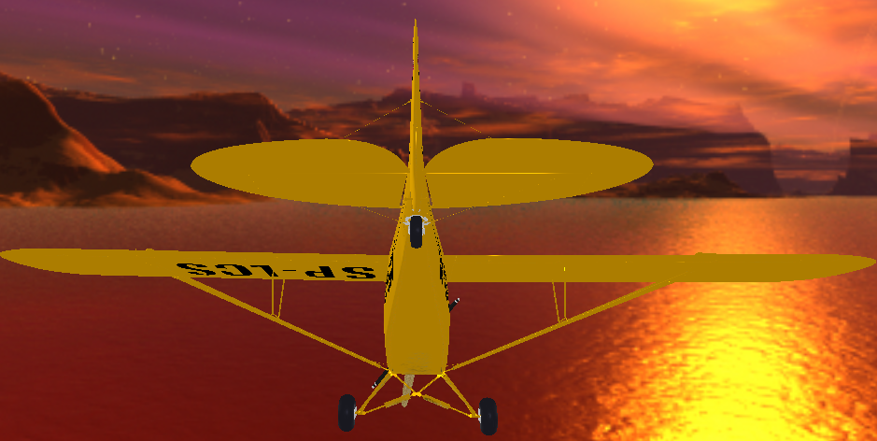 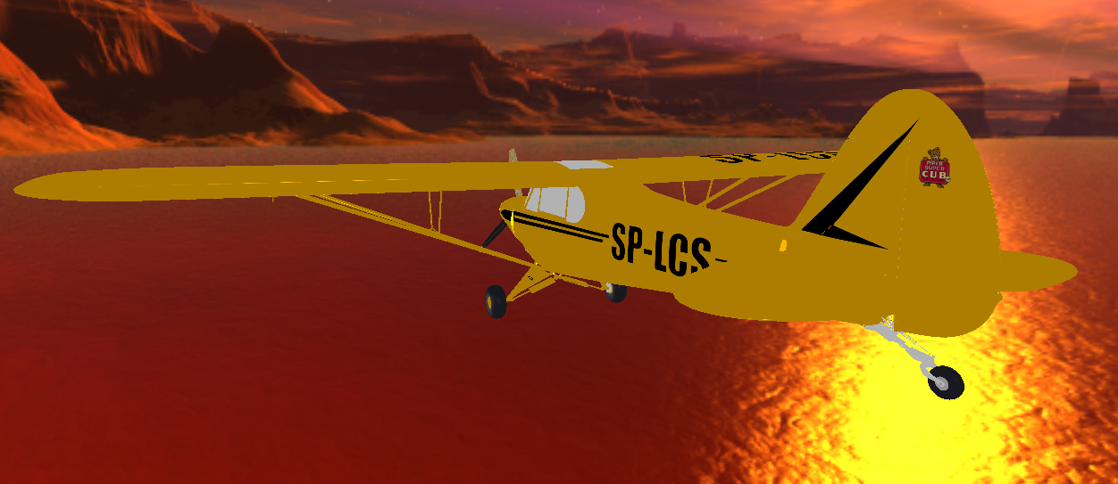 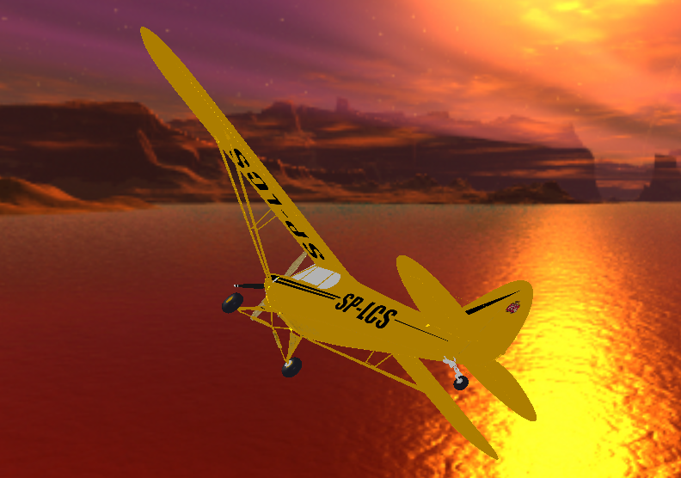

Keyboard input

Initializing Cameras

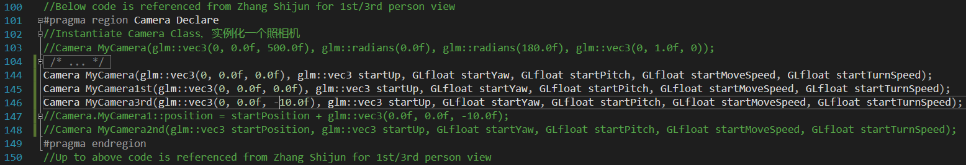

Using if loops to implement pitch, yaw and roll, as well switching between 1st with 3rd person’s view.

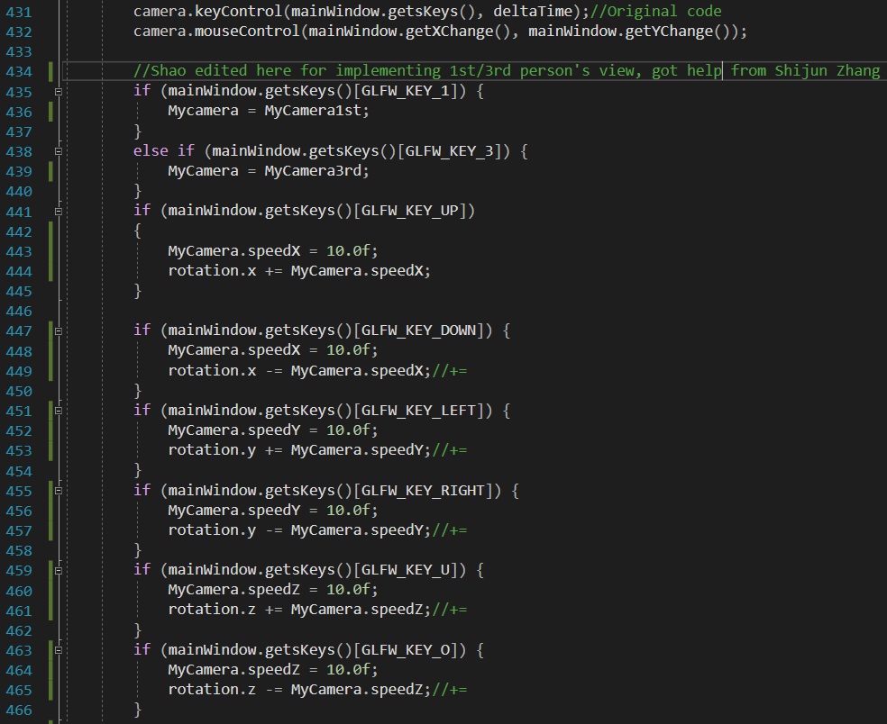

Mouse input:

In Camera.cpp, I have used below left loop to implement mouse controlling, and below right loop for updating Camera.

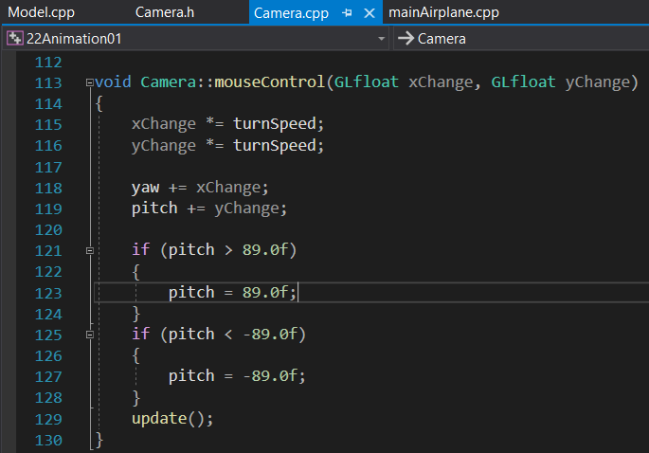 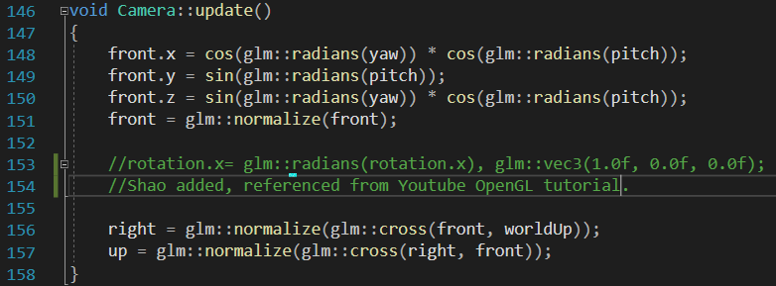

**3.GLM math Library**

I have download and included GLM library files

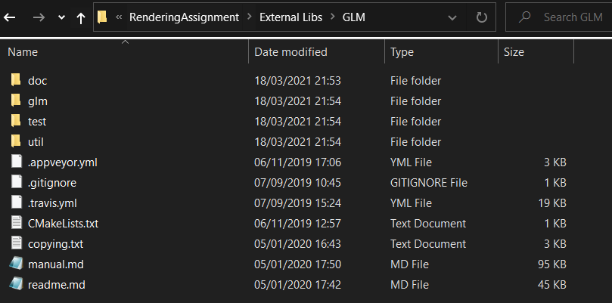

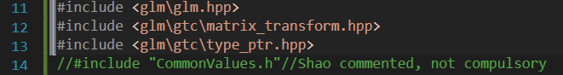

And I have used GLM library to configurate the Aeroplane model, I had referenced the structure of translation Matrix and related OpenGL materials and Video tutorials.

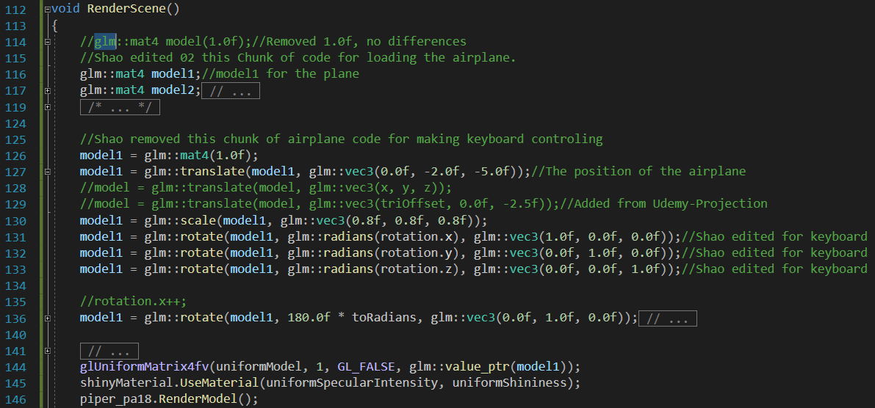

**4. Gimbal Lock, Euler Angle and Quaternions**

As I mentioned before, I studied below function to implement, euler Angle for rotation in 3D space.

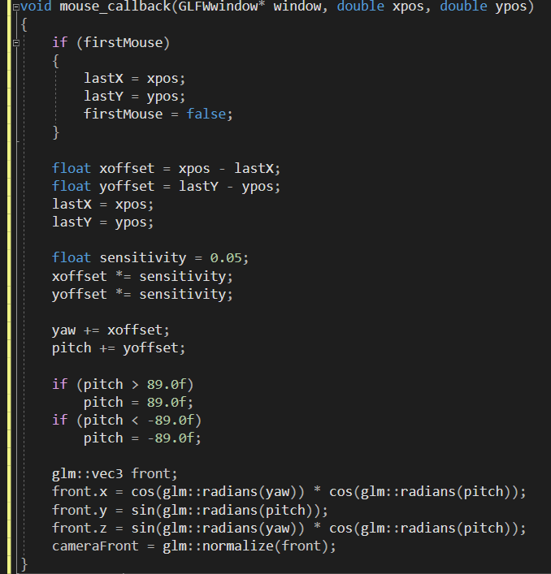

Referenced from [LearnOpenGL - Transformations](https://learnopengl.com/Getting-started/Transformations) ,the solution of Gimbal Lock is to combine all 3 matrix by first rotating around the x-axis, then Y and Z. A better solution is to rotate around an arbitrary unit axis e.g.(0.662, 0.2, 0.722) right away instead of combining the rotation matrices. To truly prevent Gimbal locks we have to represent rotations using quaternions, that are not only safer, but also more computationally friendly.

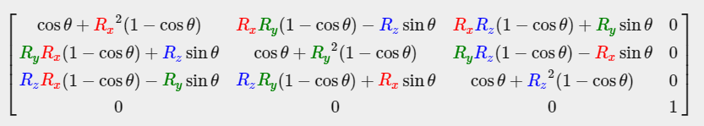

Below is the code I referenced for solving the problem of Gimbal Lock using **Quaternions.**

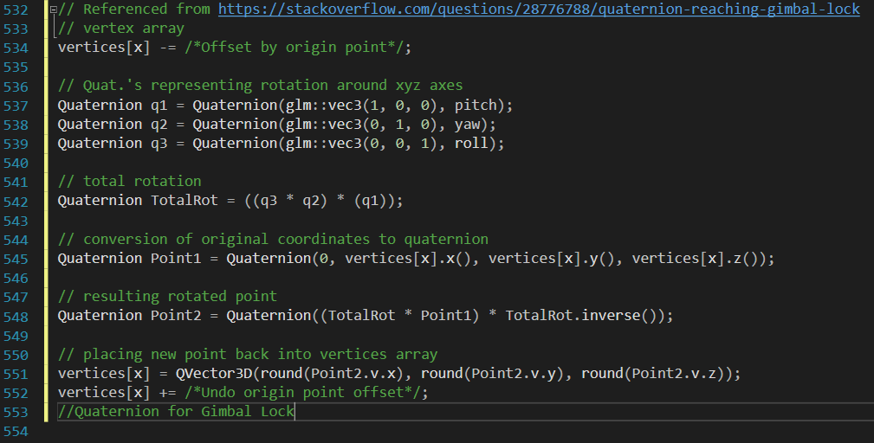

Output

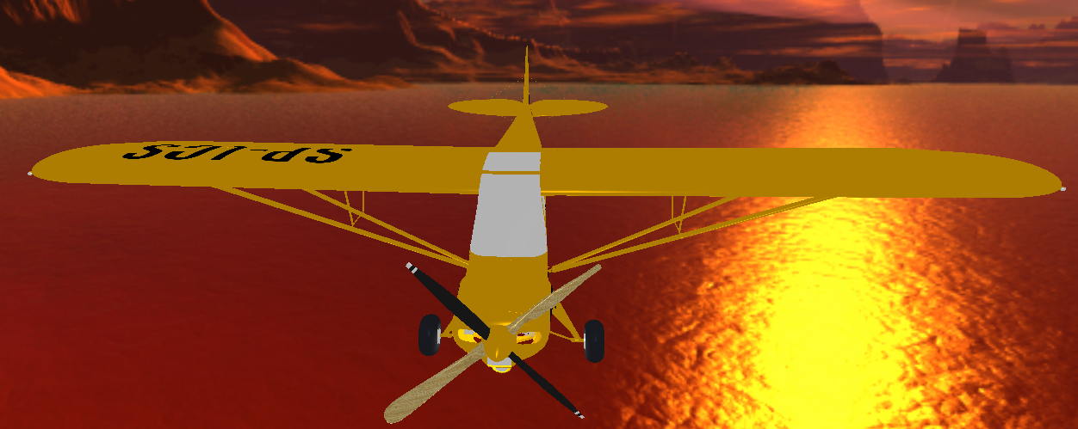 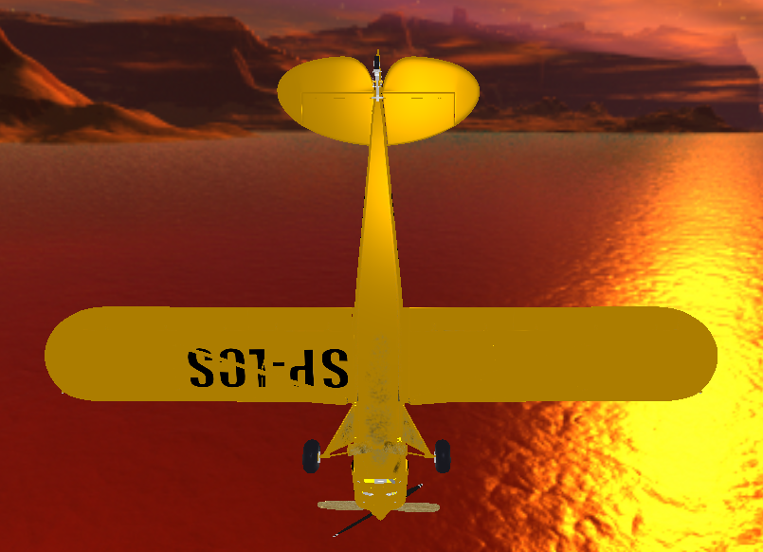 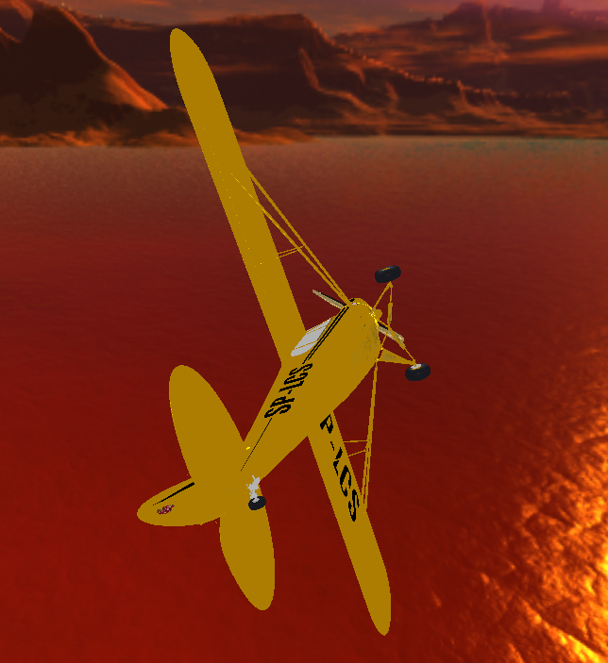

**5.Hierarchical moving elements**

I have placed the downloaded propeller here.

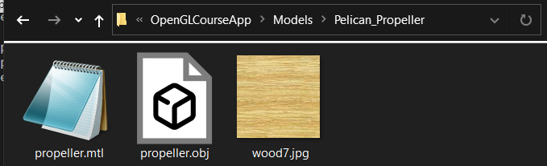

And I used model2=model2* model1; linking the propeller(model1) with the Aeroplane(model2).

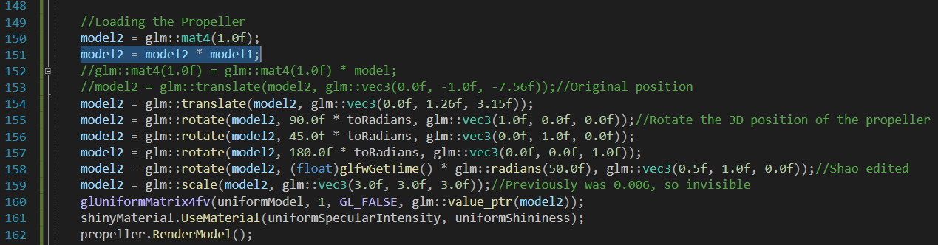

And placed the propeller in a proper position with automatic rotating using the code below.



Output( the dynamic rotating also showed on my video demo):

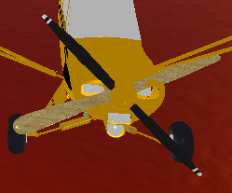 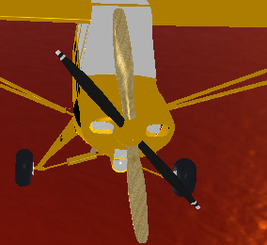 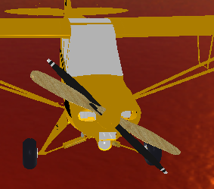

**6.Switching between 1st and 3rd person’s views**

As I mentioned above, I have created 2 Cameras and used if loop to switching them.





Another approach for making 1st/3rd persons view is using a translating function in Camera.cpp

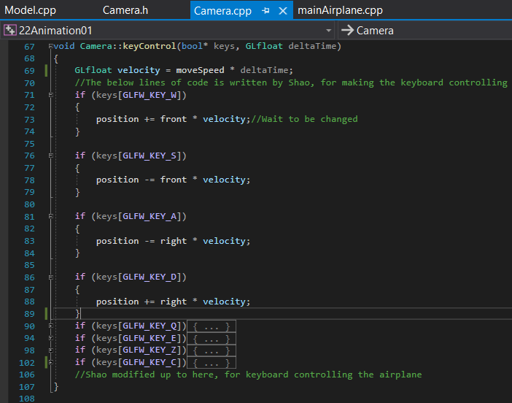

Output of 1st Person’s view

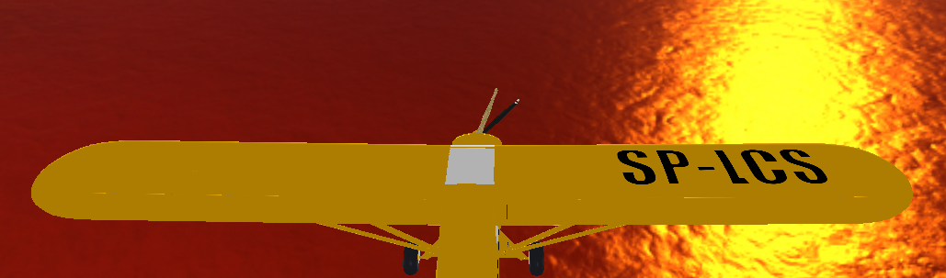

Output of 3rd Person’s view



**7.Good visual appearance of the plane**

Loading a suitable model and using a skybox makes a beautiful visual appearance.



References:

Jan Ondrej-Coordinate Spaces

Rene Schwarz-Memorandum-Quaternions and Spatial Rotation

[ch_gimballock.pdf (umd.edu)](http://www.math.umd.edu/~immortal/MATH431/lecturenotes/ch_gimballock.pdf)

[LearnOpenGL - Camera](https://learnopengl.com/Getting-started/Camera)

[LearnOpenGL - Model](https://learnopengl.com/Model-Loading/Model)

[LearnOpenGL - Transformations](https://learnopengl.com/Getting-started/Transformations)

[c++ - Quaternion reaching gimbal lock - Stack Overflow](https://stackoverflow.com/questions/28776788/quaternion-reaching-gimbal-lock)

[OpenGL + C++: Modern Graphics for Groundbreaking Games | Udemy](https://www.udemy.com/course/graphics-with-modern-opengl/)